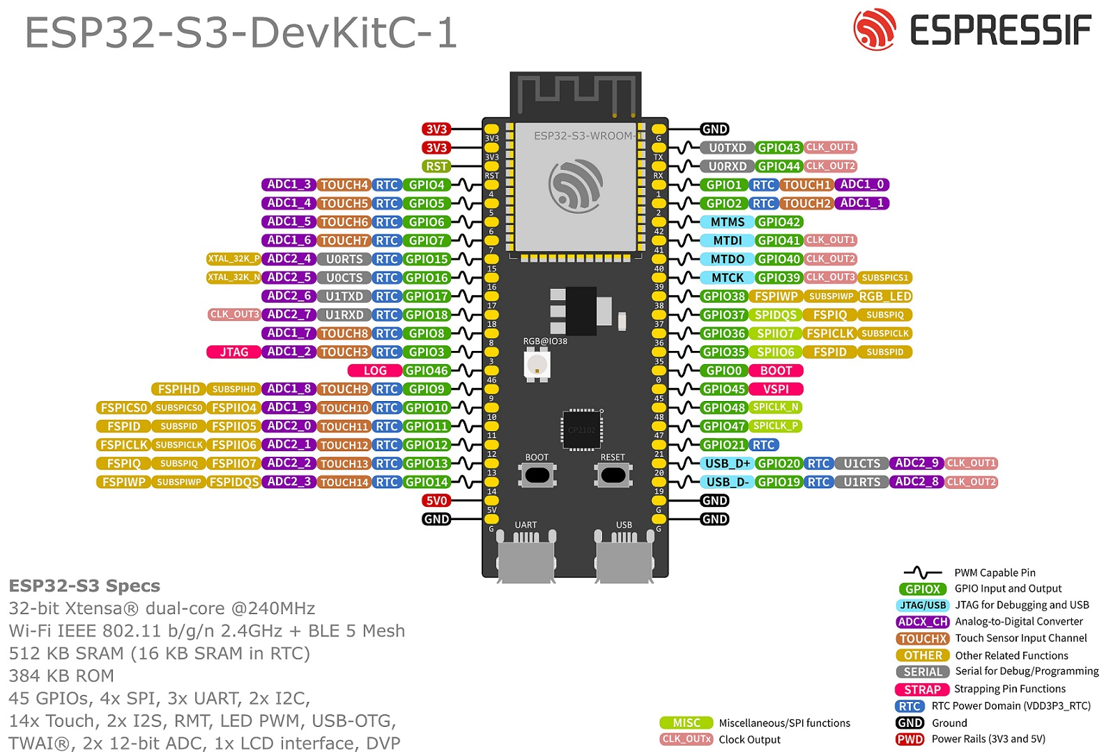

DISP: SD CARD CS (16)

TOUCH: IRQ (17)

DISP: RST (18)

TOUCH: SDA (8)

SCALE: SCK (3)

SCALE:DT (46)

TOUCH: SCL (9)

DISP: CS (10)

DISP: MOSI (11)

DISP: SCK (12)

DISP: MISO (13)

DISP: D/C (14)

PWR: 5V

PWR: GND

